Continuous Interaction Lab Solution
Running the model containing a continuous interaction between initial weight and weight loss, as well as the main effects of these variables, age, and sex, the results (Table 1) show that age does not have a significant effect on running time (p=0.43). Men run around one minute 51 seconds (111 seconds) faster than women on average (p<0.001).
Table 1: Results from the regression model.
Variable | Coefficient | Standard Error | P Value
Age | 0.306 | 0.383 | 0.427
Weight | 2.860 | 0.396 | <0.001
Weight Loss | 7.424 | 3.195 | 0.022
Sex | 111.100 | 8.020 | <0.001
Weight x Weight Loss | -0.086 | 0.036 | 0.020

The interaction between weight and weight loss is significant (Table 1) and indicates that the effect of weight lost on time taken is less for those with heavier weights (coefficient -0.086, p=0.02, which reduces the effect of the coefficients for the main effects of weight and weight loss more for those of heavier weight).
Figure 1 shows that the slopes of the lines relating Time to Loss differ for different weights, meaning that the effect of weight loss on time taken is different for different weights. For heavier people (top line) the slope is negative, so as weight loss increases time taken decreases. For people of average weight and lower weights (middle and lower lines), the slope is positive, meaning that for those people time taken increases as weight loss increases. At higher weight loss, there is a similar effect of weight and weight loss on time as indicated by the overlapping error bounds around the lines for mean weight, mean weight less 1 SD and mean weight + 1 SD.

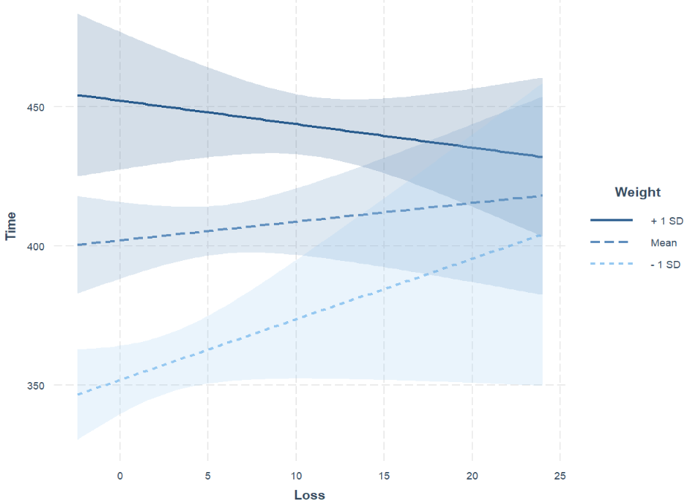
Figure 1: Interaction plot of weight and weight loss vs time.

Johnson-Neyman interval calculation found that, when weight is outside the interval (76.37, 96.75), the difference in slopes is significant at alpha=0.5. Considering when weight is 60.92, which is one standard deviation below the mean weight of 78.46, the slope of Loss is 2.18, with p=0.08. This is also shown in the results of the simple slopes analysis.
Note that results are given here for alpha=0.5, as for alpha=0.1 or 0.05, the output states that the Johnson-Neyman interval could not be found- the output for the simple slopes analysis is the same as seen below after the relevant code using alpha=0.5.

R Code and some output
exercise=read.csv("Exercise and Weight Loss.csv")

# Continuous Interaction

library(tidyverse)
library(ggplot2)
library(effects)
library(jtools)
library(interactions)
library(sandwich)

modelcon=lm(Time~Age+Weight*Loss+Sex, data=exercise)
summary(modelcon)

#interaction plot
interact_plot(modelcon, pred = Loss, modx = Weight, plot.points=TRUE)

# add confidence bands
interact_plot(modelcon, pred = Loss, modx = Weight, interval=TRUE, int.width = 0.8)

# simple slopes

ss=sim_slopes(modelcon, pred = Loss, modx = Weight, johnson_neyman = FALSE)

library(huxtable)
as_huxtable(ss)

Output:
Value of Weight Slope of Loss
───────────────────────────────────
60.92 2.18 (1.25)#
78.46 0.67 (0.95)
96.00 -0.84 (1.02)

#johnson-neyman
sim_slopes(modelcon, pred = Loss, modx = Weight, johnson_neyman = TRUE, jnalpha=0.5,
control.fdr = TRUE)

Output:
JOHNSON-NEYMAN INTERVAL

When Weight is OUTSIDE the interval [76.37, 96.75], the slope of Loss is p < .5.

Note: The range of observed values of Weight is [50.00,137.00]

Interval calculated using false discovery rate adjusted t = 0.88

SIMPLE SLOPES ANALYSIS

Slope of Loss when Weight = 60.92307 (- 1 SD):

Est. S.E. t val. p
------ ------ -------- ------
2.18 1.25 1.74 0.08

Slope of Loss when Weight = 78.46000 (Mean):

Est. S.E. t val. p
------ ------ -------- ------
0.67 0.95 0.70 0.48

Slope of Loss when Weight = 95.99693 (+ 1 SD):

Est. S.E. t val. p
------- ------ -------- ------
-0.84 1.02 -0.82 0.41

